**Output process**

1. **Encoding Process**

Open terminal, enter the command

*python encoder.py*

Window will be opened,

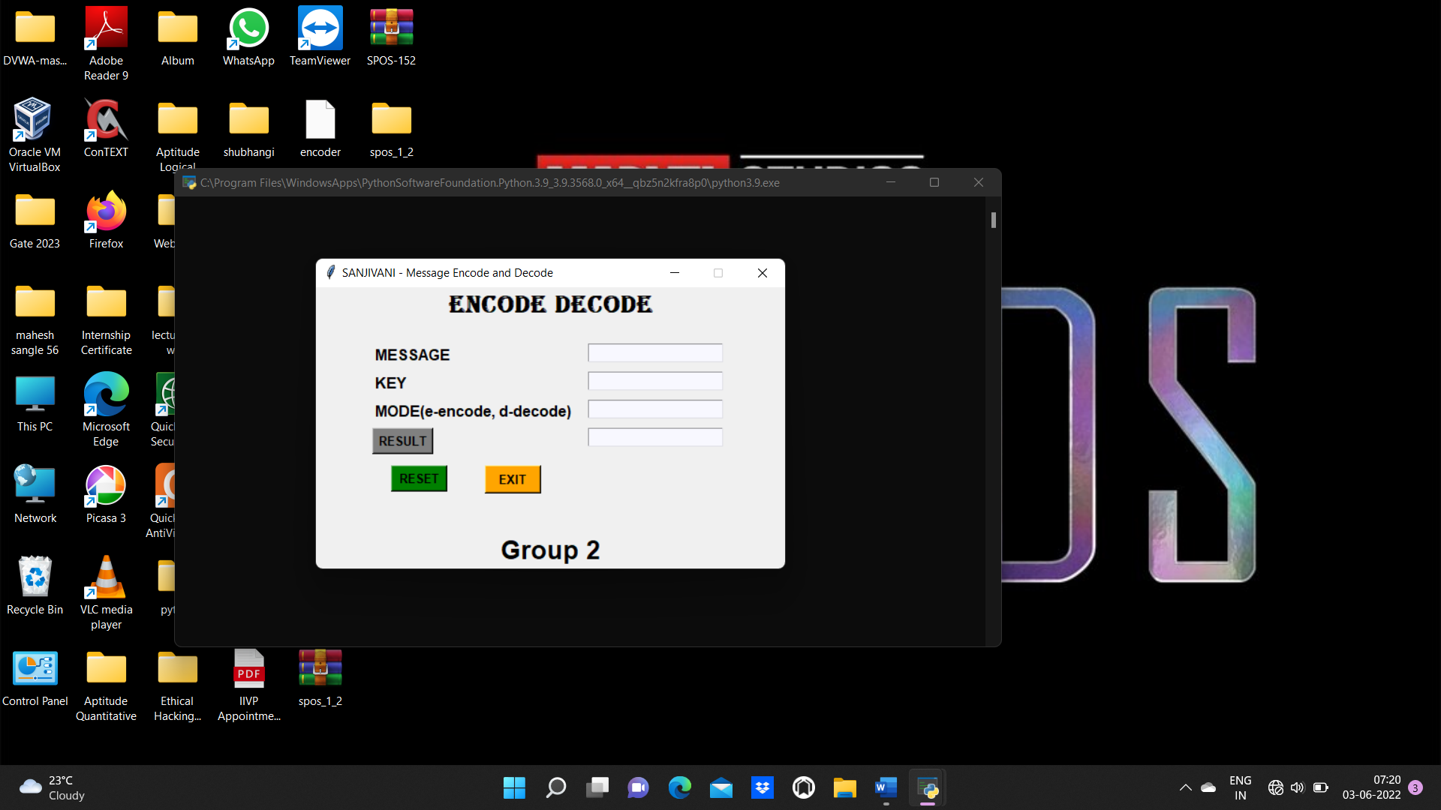

Enter the message,

E.g. Sanjivani

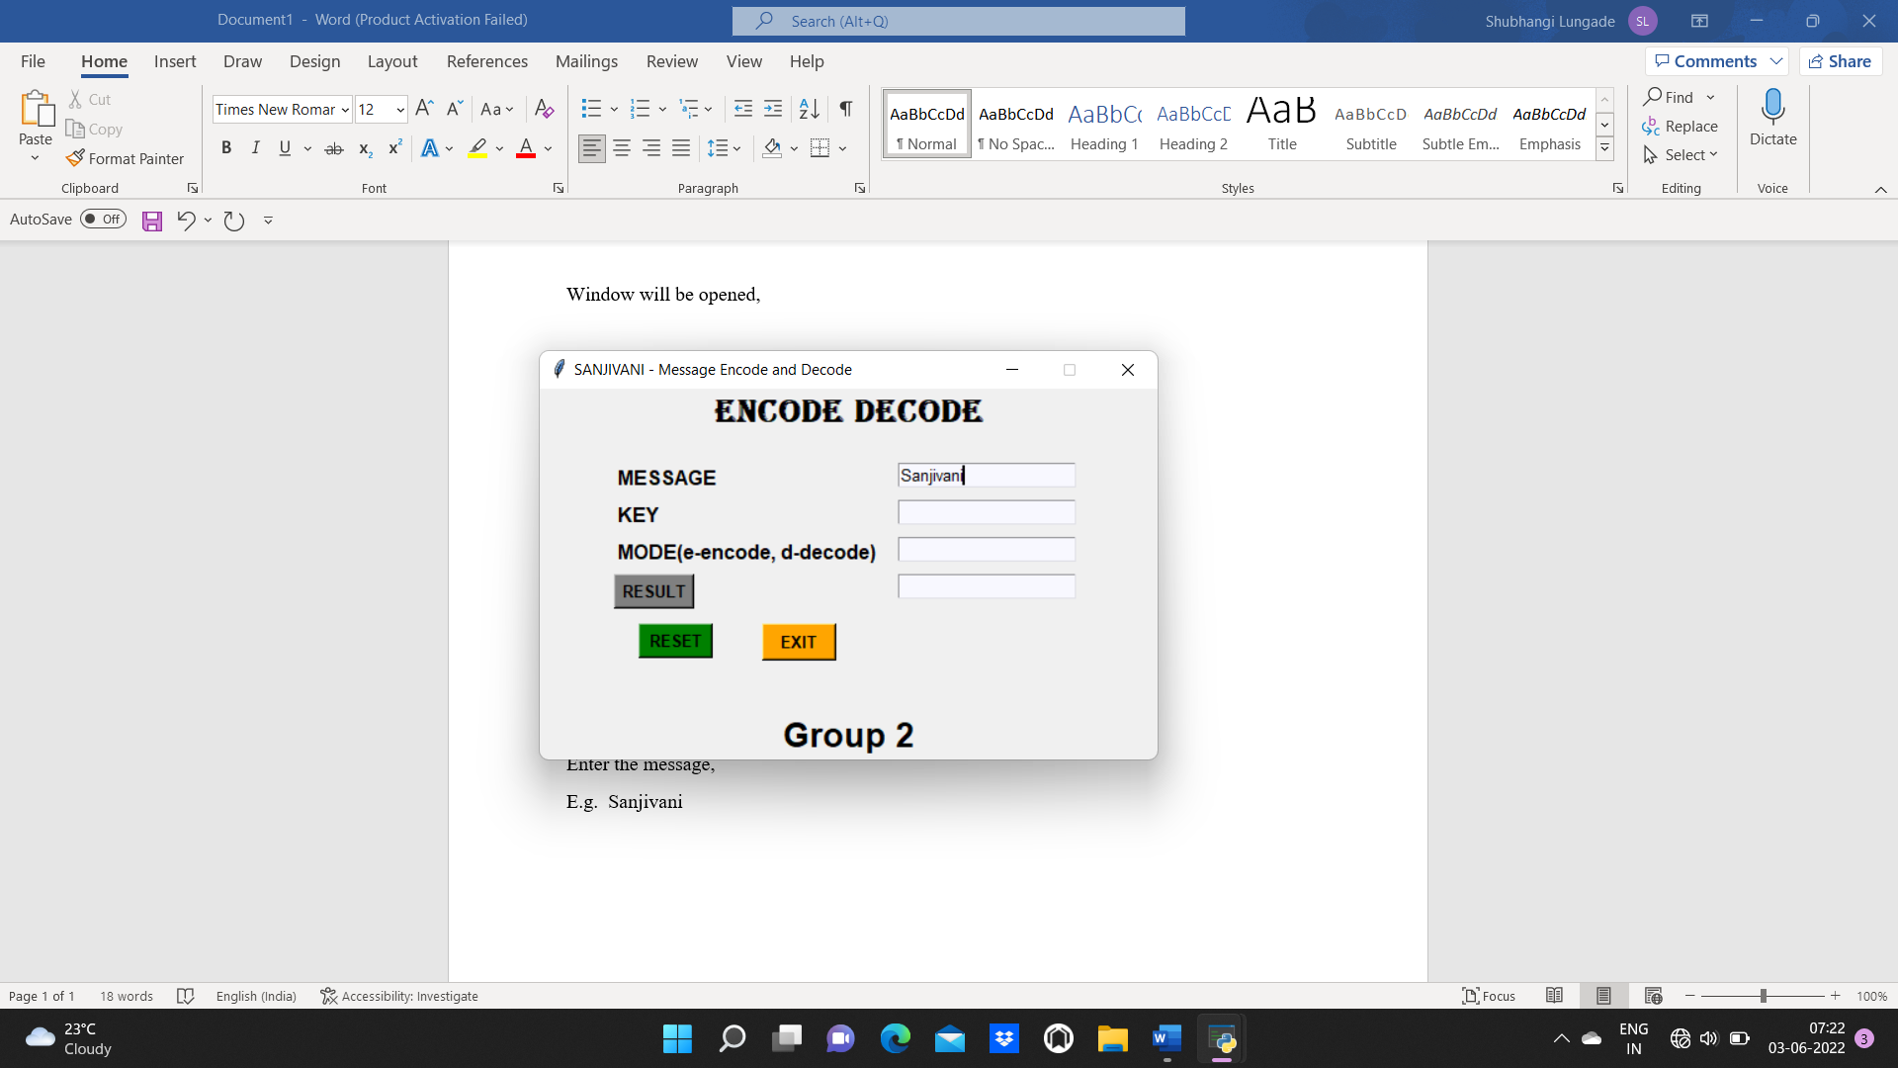

Enter the key,

e.g., it

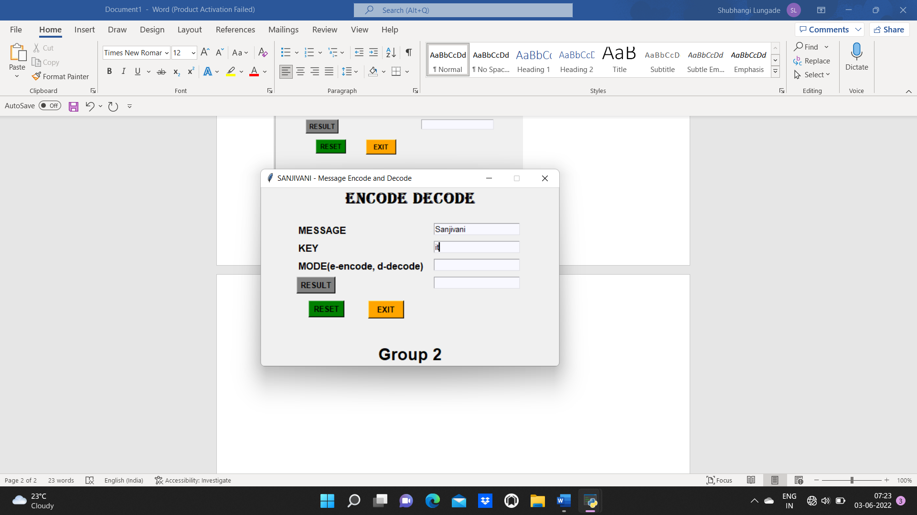

Enter the mode as ‘e’ for encoding,

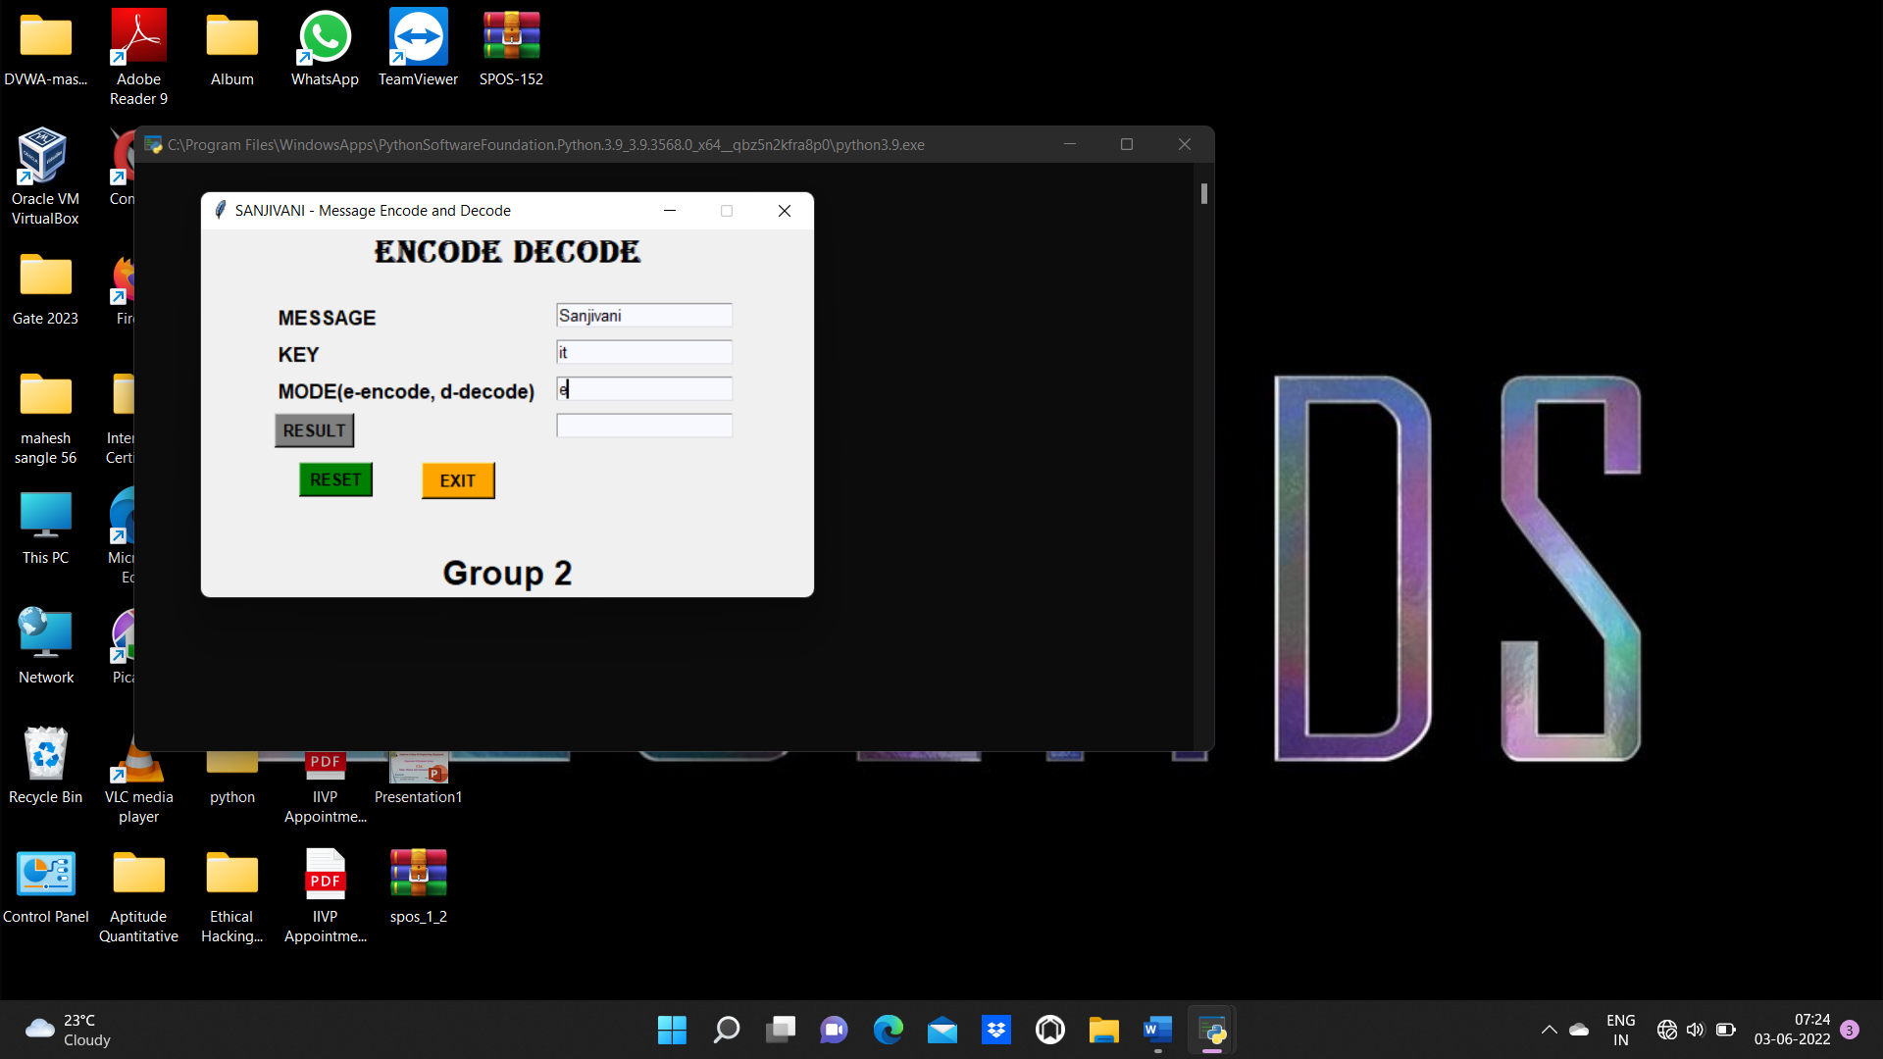

Click on Result button, to get the encoded message

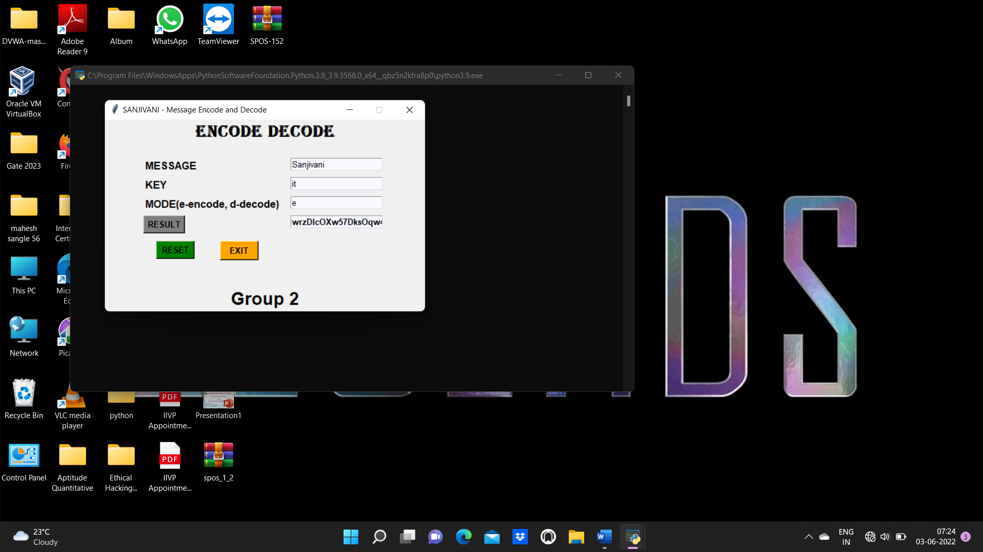

1. **Decoding Process**

Copy the encoded result, and paste in the message as a input, and keep the key same

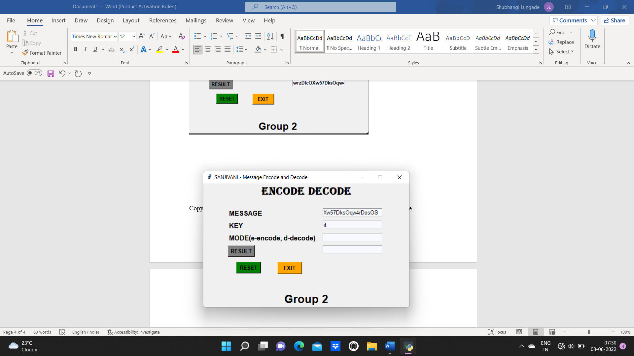

Now enter the mode as ‘d’ for decoding

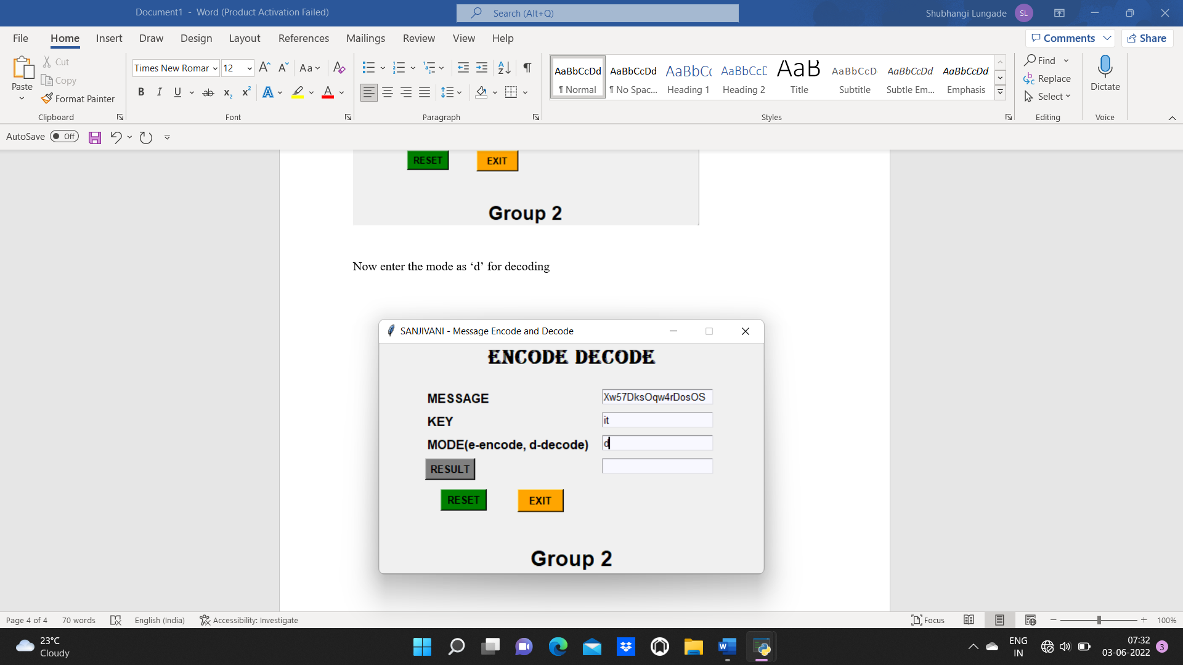

Again, click on the Result to get the decoded output

E. g. As key is same and encoded message is of message ‘Sanjivani’, so the output should be ‘Sanjivani’.

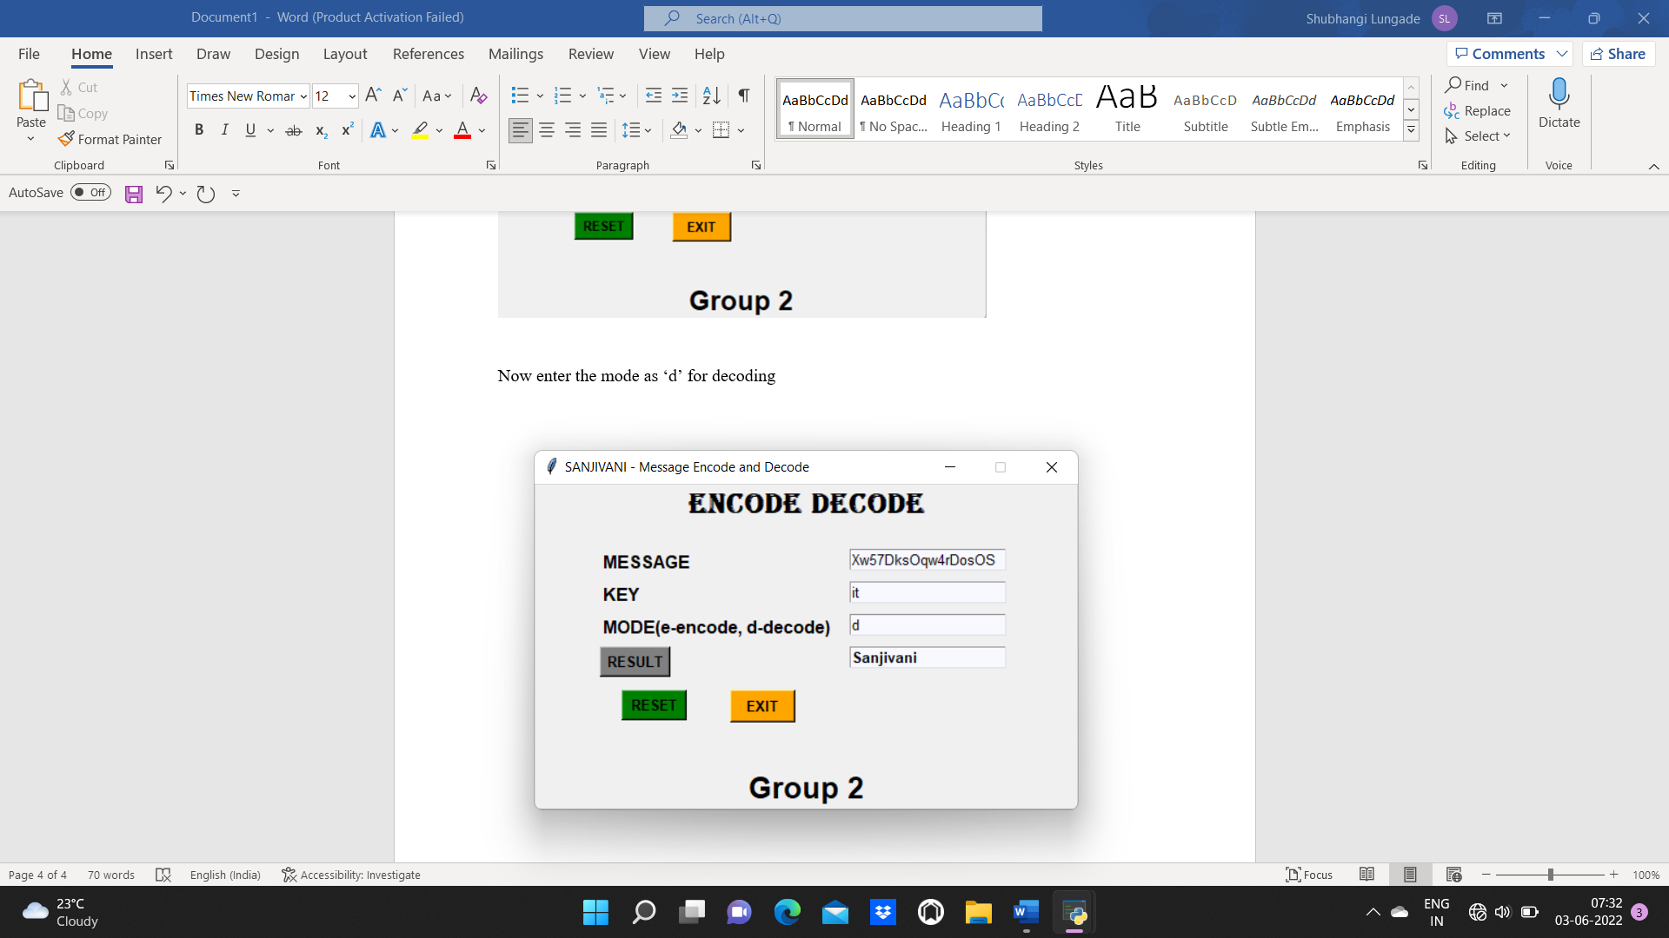

1. **Reset**

Click on reset button for resetting the window

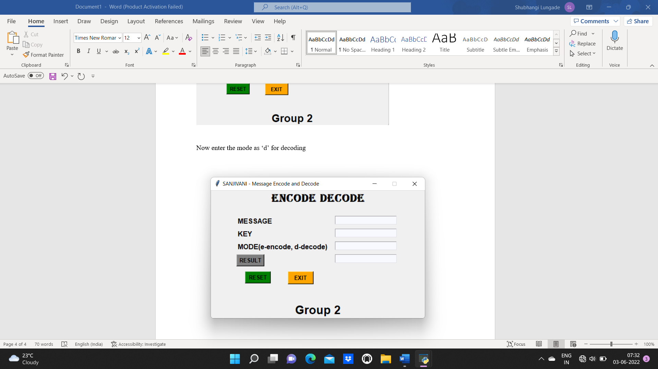

1. **Exit**

Click on exit button for exiting the window.

The window will disappeared.